Flipping the Classroom: The Ultimate Engaging Experience

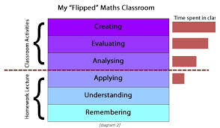
Definition of flipped classroom

Key elements of the flipped classroom
- Provide an opportunity for students to gain first exposure _______ to class.
- Provide an _______________ for students to prepare for class.
- Provide a mechanism to ___________ student understanding.
- Provide in-class activities that focus on _______________ activities.
7 Things You Should Know……
- In your words, what is a flipped classroom?

- How does it work?
____________________________ followed by in-class exercises

- Who’s doing it?
Rapidly gaining popularity everywhere

- Why is it significant? Lectures (content) is put in the control of the ______________

- What are the downsides? Careful _____________________
- Where is it going? _______________ may emerge

- What are the implications for teaching and learning?

Handout – Vanderbilt University Center for Teaching – “Flipping the Classroom,” by Cynthia Brame and “7 Things You Should Know About Flipped Classrooms”, Educause Learning Initative

